Ideation Phase

Define the Problem Statements

|  |  |
| --- | --- |
| Date | 19 September 2022 |
| Team ID | PNT2022TMID43957 |
| Project Name | Project – Plasma Donor Application |
| Maximum Marks | 2 Marks |

**Problem Statement:**

During the COVID 19 crisis, the requirement of plasma became a high priority and the donor count has become low. Saving the donor information and helping the needy by notifying the current donors list, would be a helping hand. In regard to the problem faced, an application is to be built which would take the donor details, store them and inform them upon a request.

Lydia is thirty-five years old. She was affected by COVID-19 and had been admitted in the hospital. Due to COVID, her immunity power became low. She immediately wants a plasma donor. Here, she checks the availability of the plasma donor through our plasma donor application. She checks for the matching criteria of the donor through our application and also verifies whether the donor is within the range(location). Then after finding a perfect donor, he/she donates the plasma. Thus, our application is useful for a COVID patient to improve the immunity and blood circulation.

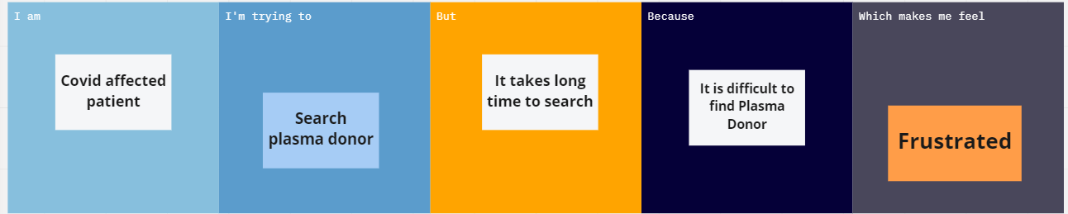

|  |  |  |  |  |  |
| --- | --- | --- | --- | --- | --- |
| **Problem Statement (PS)** | **I am (Customer)** | **I’m trying to** | **But** | **Because** | **Which makes me feel** |
| PS-1 | Covid affected patient | Search Plasma donor | It takes long time to search | It is difficult to find plasma  donor | Frustrated |
| PS-2 | Volunteer | Donate plasma | I don’t know to start | It is difficult to find who need plasma(who  needs donation) | Sad |